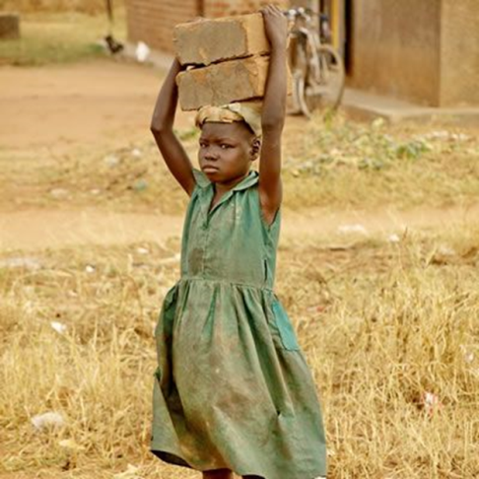
2016 Annual Report
Millions of girls in rural and remote areas of Tanzania, (especially southern part of the country) those of primary school age are not in school. Take your Love and make something out of it!

Our mission is to promote initiatives of the marginalized and disadvantaged women, youth, girls and children, to design solutions for social, economic and poverty problems affecting quality of life, now and for the future.

Let we educate African girls and stop child labour!

Table of contents:
1. Letter from President
2. The Legacy of Neema Edward Mkwelele
3. Rural and remote area of Tanzania (southern Tanzania)
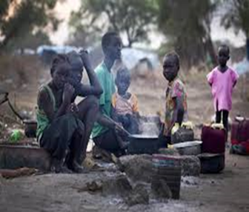
4. Mtwara – project host region
5. Call for help

Letter from the President.

Dear Friends of Neema Edward Mkwelele Wellness Foundation,
Neema was very much interested in education and community development in such away it compelled people around her community to think about the establishment of the foundation in her name so as to keep alive her interests and at the same time she will act as a role model to be emulated by others, especially young girls throughout the country, Africa and the rest of the world. Therefore, the project - first program is the memorial school and the legacy. The school will be a special tool to providing primary education to disadvantaged and poor girls in rural and remote Tanzania; removing and rescuing vulnerable girls especially those from rural and remote areas of southern Tanzania. Neema Foundation School will enhance Neema’s legacy, and therefore, the legacy of Neema Edward Mkwelele will be a mirror to lead everyone involved throughout the process of helping to educate poor and underprivileged girls. More important to me is that we strongly believe that Neema’s achievements will inspire other girls to follow her footsteps and accomplish beyond her accomplishments.

We are very pleased to see how we are making progress and we have just wrapped up the first phase (project introduction and definition phase) and now moving to the second phase and it will take us about three years. We’re also very optimistic that maybe by 2020 we will complete school buildings and we might start receiving girls to join Neema Foundation School (a memorial primary school). We estimate that the capacity of the school will be to take 45 students in each class, and the school will continue to maintain a number of 315 students each year. The program capacity will is clearly established; more work and resources is needed to achieve this goal so as to reach out to so many poor children especially girls. One girl at a time!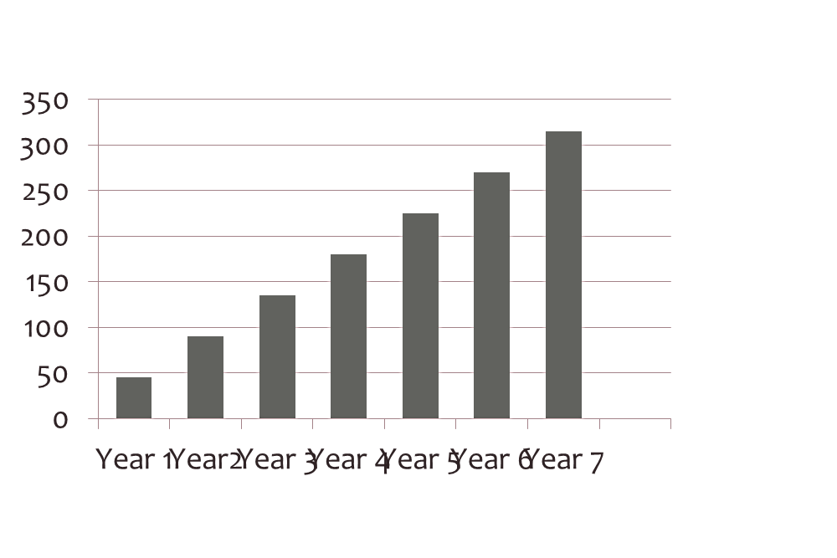Target: To reach out; rescue and education 315 girls per year.

Therefore, I optimistic and hope that we will be able to join others who are doing their best in protecting children from violence, abuse, neglect, and poor treatment. I also would like to insist that if you’re passionate about change especially making a better life for poor children in a poor Tanzania then Neema Edward Mkwelele Wellness Foundation is excellent match.

Looking ahead in 2017, Neema Edward Mkwelele Wellness foundation will continue its fundraising (on-line fundraising – we will work on getting our new website up and running) to reach the funding goal for building a memorial school and working hard to securing partnerships.

Thank you for your support.
Sincerely,
Edward Mkwelele
President/Co-Founder

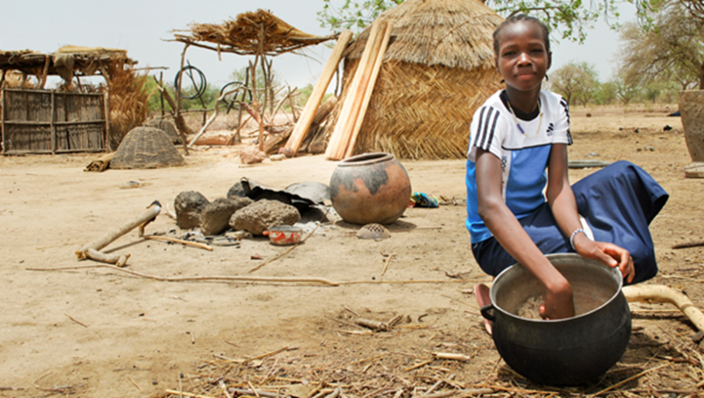
Our vision is that within a generation, society globally and Tanzanians will act on the understanding that we are all better off when girls and women are able to go to school. Therefore, our vision is to support girls and give them education and empower them to live their dreams by giving them basic education (primary education).

2016 Annual Report
Get involved, visit our website: www.neemaedwardwellnessfoundation.org.
P.O. BOX 77583,Dar-Es-Salaam, Tanzania.

The Legacy of Neema Edward Mkwelele

Why We Exist?
We exist to protecting children from violence, abuse, neglect, and poor treatment; our focus will be to rescue the vulnerable girls and achieving one goal; which is removing barriers to girl’s education. We will work in areas where there are high levels of poverty and we will thrive at cutting off the vicious cycle of poverty and generational child labour and teenage pregnancies. We’re hopeful that if we remain laser-focused and enlist others to join us, we can continue providing primary education to disadvantaged and poor girls in rural and remote Tanzania.
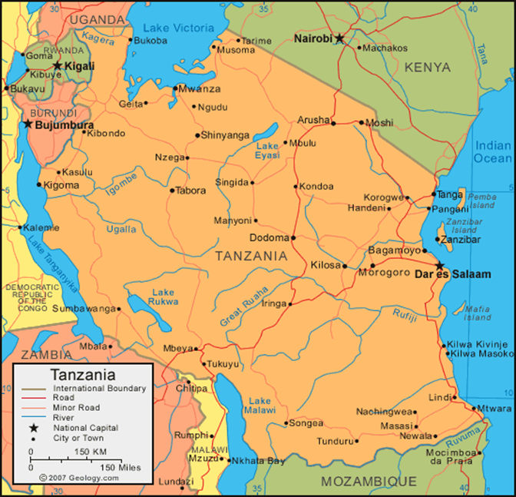
Rural and remote area of Tanzania (southern of Tanzania)
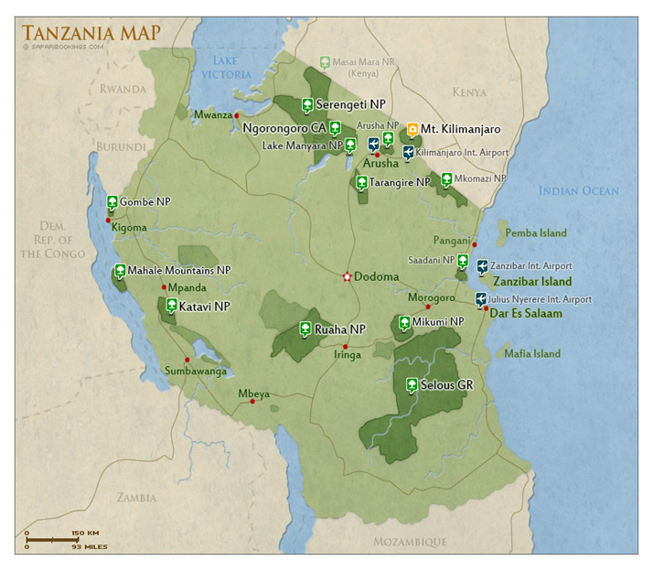

The location of our project; Neema Edward Mkwelele Wellness Foundation and Neema Foundation School will be very far from our office in Dar-Es-salaam. We have chosen the rural and remote southern Tanzania because in comparison with other regions, this region is very poor with less economic activities; Mtwara region.

About the country
The United Republic of Tanzania is an emerging economy with high potentials. But, despite of impressive growth in its gross domestic product (GDP) over the past decades, it remains one of the world's poorest countries in terms of per capita income. Total population is estimated to be 50, 757,459. Population counting of 2014, and where the rural population stand at 35, 072, 897.

Why this location?
It's simple: In the world's poorest communities, girls and women bear the brunt of poverty. Therefore, girls and women in these areas are very poor. And this an opportunity for Neema foundation to join government efforts, other agencies to help and support vulnerable girls – meaning these girls will attend school and enjoy the right of girls to be free of school-based Gender Violence: The project will also use this opportunity to support the government efforts to reduce poverty among girls and women in rural areas.

It is very important to remember that educating girls is one of the most powerful tools for alleviating poverty especially in rural areas. It is also fundamentally important to remember that the best way to empower a girl is to support her education

Mtwara – project host region
Mtwara is one of regions in southern region of Tanzania: (Mtwara and Lindi regions) of the United Republic of Tanzania.

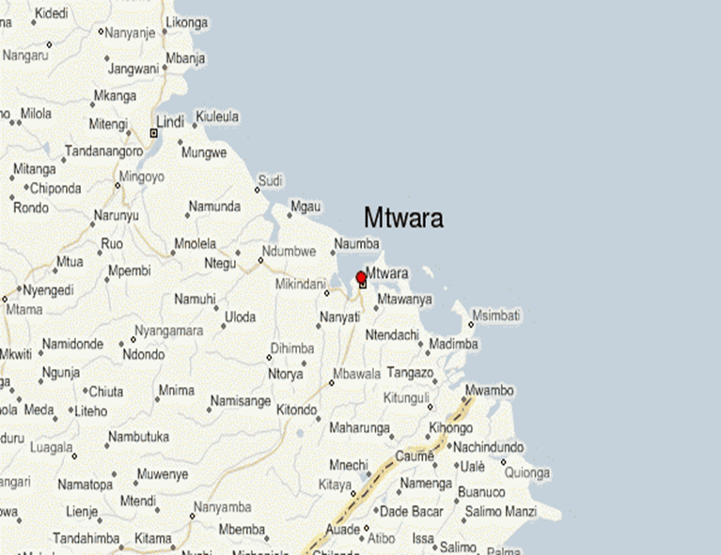

The geographic area of focus, Mtwara and Lindi are characterized by poverty and backwardness in education especially for girls. Most people are living in rural areas and are extremely poor. Tanzanian women have higher rates of poverty than Tanzanian men. The first and foremost focus is to reduce poverty in rural areas.

Poor infrastructure in the rural areas partly account for this trend. Neema Edward Mkwelele Wellness foundation main focus is to educating children; education is fundamentally important and specifically to girls - who are at compulsory school age of primary school level.

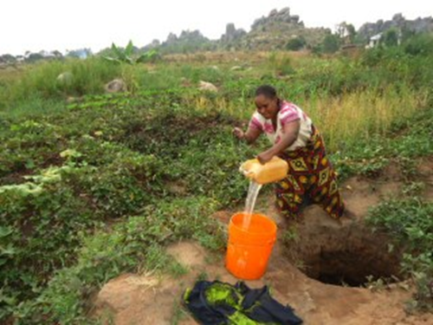
Project (the foundation) brings optimism to the community.
Community Benefits:
The long-term benefits of project – Neema foundation school;
First and foremost, direct benefit = the community will see increasing number of well-educated children especially girls. The project will increase economic activities in this area because the southern regions and southern cost have less economic activities compared to other part of the country. Including;
(a) Providing Clean and safe water. Neema Foundation will bring clean and safe water to its project location from the nearest rivers for its project (the school) and people community living around the project will benefit too.
(b) The Neema Edward Mkwelele foundation will facilitate the process of getting accessible road – The foundation will work with the government and/or other agencies to contract and/or clear forest to get a clear, manageable and accessible road.
(c) The Neema Edward Mkwelele foundation will also facilitate the process of getting accessible primary health services – the school dispensary will provide service to school and children and the community living around the school.

Call for help:
We would like to invite you and your contribution is very important to us. We need your support and help!

