2021 Annual Report

2021: Another Tough Year
I want to acknowledge that 2021 has been another long, tough year. At Neema Foundation we say we got through it, despite all the challenges, and there is a silver lining.

It’s inspiring to think this way that it has been a remarkable year for progress in our work, and I want to extend my deepest thank you to our supporters.

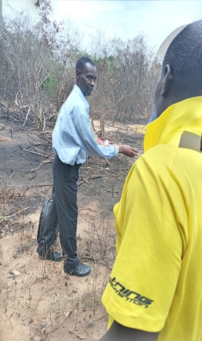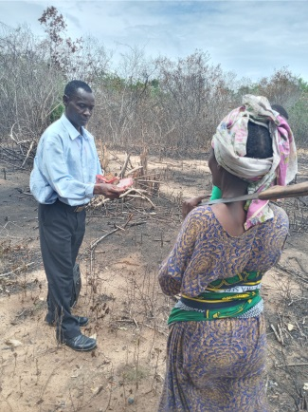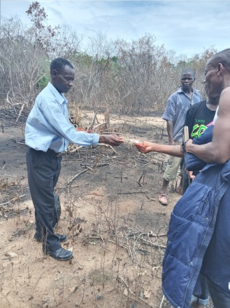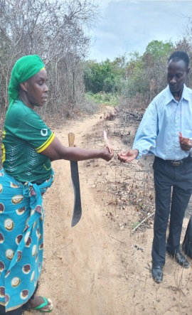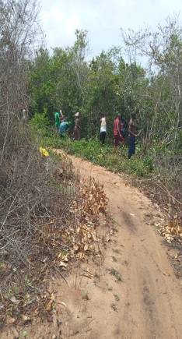

Neema Foundation increased local people participation, part of community engagement and provided land cleaning up work to Nachia village, men and women getting equal opportunity and community benefits, we paid 44 people so far. We offered this work to increase employment whenever possible, aiming at promoting local economic development.

We got through it thanks to our supporters.

I believe now is the time to dedicate our energy to a brighter future in 2022.

Call for help:
We would like to continue to invite you and your contribution is very important to us. We need your support and help!

Get involved, visit our website: www.neemaedwardmkwelelewellnessfoundation.org
Thank you for your support!

Sincerely,
Bertha Mkwelele.
Executive Director and Co-Founder.

